Aplicaciones Receptivas
https://flutter.dev/docs/development/ui/layout/responsive
Hay dos enfoques básicos para crear aplicaciones de Flutter con diseño receptivo:LayoutBuilder y Mediaquery:of

Otros widgets y clases útiles para crear una interfaz de usuario receptiva:
- AspectRatio
- CustomSingleChildLayout
- CustomMultiChildLayout
- FittedBox
- FractionallySizedBox
- LayoutBuilder
- MediaQuery
- MediaQueryData
- OrientationBuilder
https://medium.com/flutter-community/build-responsive-uis-in-flutter-fd450bd59158
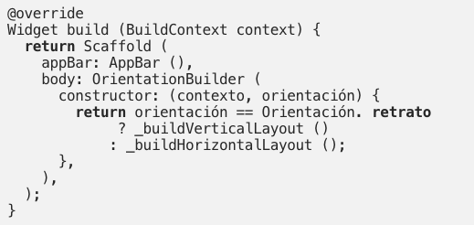

We can also check the orientation at any point in the code (inside or outside the OrientationBuilder) using
MediaQuery.of(context).orientation
Note: For that time when we’re lazy and/or only portrait will do, use
SystemChrome.setPreferredOrientations(DeviceOrientation.portraitUp);

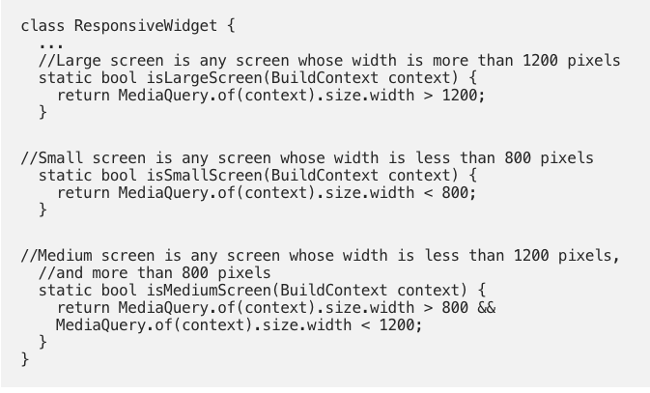
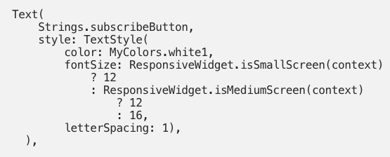

https://stackoverflow.com/questions/49704497/how-to-make-flutter-app-responsive-according-to-different-screen-size

class SizeConfig {
static MediaQueryData _mediaQueryData;
static double screenWidth;
static double screenHeight;
static double blockSizeHorizontal;
static double blockSizeVertical;
static double _safeAreaHorizontal;
static double _safeAreaVertical;
static double safeBlockHorizontal;
static double safeBlockVertical;

void init(BuildContext context){
_mediaQueryData = MediaQuery.of(context);
screenWidth = _mediaQueryData.size.width;
screenHeight = _mediaQueryData.size.height;
blockSizeHorizontal = screenWidth/100;
blockSizeVertical = screenHeight/100;
_safeAreaHorizontal = _mediaQueryData.padding.left +
_mediaQueryData.padding.right;
_safeAreaVertical = _mediaQueryData.padding.top +
_mediaQueryData.padding.bottom;
safeBlockHorizontal = (screenWidth - _safeAreaHorizontal)/100;
safeBlockVertical = (screenHeight - _safeAreaVertical)/100;
}
}

Function hp = Screen(MediaQuery.of(context).size).hp;
Function wp = Screen(MediaQuery.of(context).size).wp;

flutter_responsive_screen: ^1.0.0

Function hp = Screen(MediaQuery.of(context).size).hp;
Function wp = Screen(MediaQuery.of(context).size).wp;

Example :
return Container(height: hp(27),weight: wp(27));

